LLP114

Cybersecurity and Forensics

Network Discovery using NMAP on a domestic router and virtual machine.

Sohag Noman – F434565

**Abstract**

Routers these days can be considered as a standard device in every household that allows us to obtain Internet connection. Customers frequently receive this router from their Internet service provider ([ISP](https://en.wikipedia.org/wiki/Internet_service_provider)), and it is typically pre-configured and ready for use. Unfortunately, most routers have inadequate security settings by default, and they can easily become a target for cyber-attacks because of this inadequate security settings, which exposes them to several vulnerabilities. This research aims to explore how [‘Nmap’](https://nmap.org/) , a network scanner, can be used to discover devices connected to a network by sending packets and analysing the responses. Then, to determine whether a communication can be established and what risks a machine can encounter during this communication.

1. **Introduction**

**1.1 Background Information**

Home routers are becoming a standard equipment in every home with an Internet connection. Customers frequently receive this router from their Internet service provider (ISP), and it is typically pre-configured and ready for use. The user can instantly connect to the Internet after setting up their login information and connecting their domestic devices to the router. (Karamanos, 2010) Usually, users don't make any further configurations because they find it too complicated or because they would rather utilise the service right away than deal with complicated router configuration details. This can be considered a poor practise as it leads hackers to target these sorts of vulnerabilities. A first step before conducting any sort of cyber-attack requires gathering information on the target and it is commonly de-fined as “reconnaissance”. (Mazurczyk and Caviglione, 2021)

**1.2 Research Problem**

Routers are essential for Wi-Fi connections, with millions of new devices set up daily in homes and workplaces. (Kaspersky, 2022) Any device connected to a network through a router, be it a printer, router, or web server, necessitates open ports to accommodate connection requests. (Wattuhewa, 2023) The functionality of the device is significantly impacted by the existence or lack of these open ports. While having too many open ports can expose the device to possible attacks, not having the right ports open can cause problems with operation. Nmap is a powerful tool that allows users to conduct comprehensive scans of network devices, identifying which ports are open.

**1.3 Aims and objectives**

The aim of this research is to model the reconnaissance phase carried by a hacker to understand what devices are connected to a network and if a connection can be established. To meet this aim, the research seeks to achieve the following objectives:

o   Explain how devices are connected to the internet in a domestica router/ network.

o   Gather information about these devices, scan all the ports available to establish a connection.

1. **Literature review**

The landscape of the internet connectivity has progressed dramatically over the past two decades, and at the heart of this evolution ISP has played a key role. In the figure below we can see the evolution of internet connectivity.

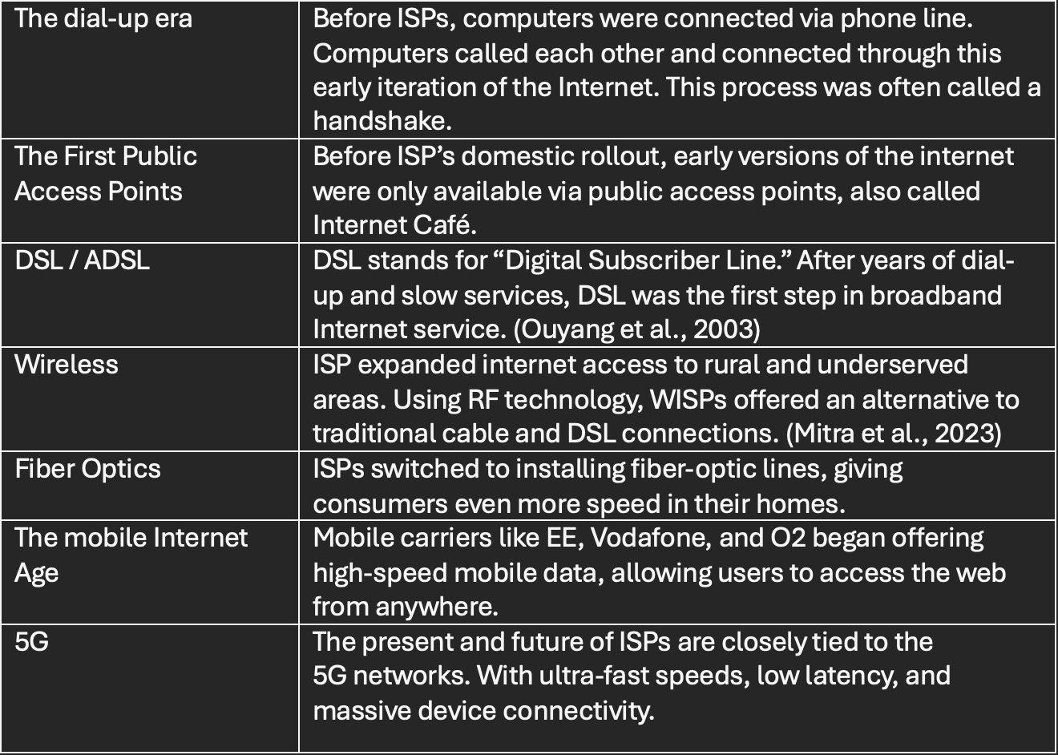

Internet technology has spread and entered a stage of rapid development. Internet makes human life connected but it is also accompanied with some risks such as the cyber-attacks which will lead to business interruption or data leakage, causing incalculable economic losses. (Liao et al., 2020) The [(Mazurczyk and Caviglione, 2021)](https://csrc.nist.gov/glossary/term/cyber_attack) (National Institute of Standards and Technology) defines as a cyber-attack *‘Any kind of malicious activity that attempts to collect, disrupt, deny, degrade, or destroy information system resources or the information itself*.’

In the figure below we can we how mainstream devices such as laptop, smartphones or PCs communicate over the internet.



Typically, every cyberthreat has a different level of complexity, and not all attacks have the same objective, effect, or scope. The literature does, however, concur that an attack can be broken down into a few stages. There are different attacking models ([Cyber Kill Chain, Mitre attack](https://www.royalholloway.ac.uk/media/20188/techreport-2022-5.pdf.pdf)) (Ferazza, 2022) but the first step always requires gathering information on the target and it is commonly defined as “reconnaissance.” (Mazurczyk and Caviglione, 2021)

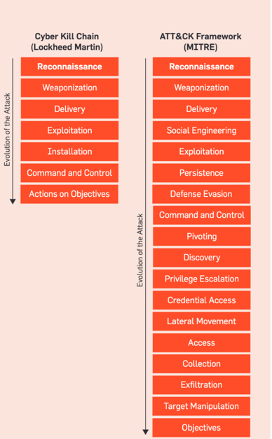

In general, reconnaissance relies upon information gathering. A reconnaissance attack is also known as information gathering, is the first phase of a cyber-attack. It is anunauthorized retrieval of information about a target to identify vulnerabilities that an attacker can exploit. (Odun-Ayo et al., 2022) Tevolution of the Internet, the diffusion of online social networks, as well as the rise of services for scanning smart appliances and IoT devices can make the reconnaissance phase quicker, easier, and more effective. (Mazurczyk and Caviglione, 2021)

One of the way to execute a reconnaissance attack is through scanning. Network scanning involves identifying which hosts that are alive in the computer network, which operating systems that they use, and what services they run. (Holm, 2012) Nmap (Network Mapper) is one of the most widely used open-source tool for network exploration and security auditing. It is designed to scan and map networks, discover hosts, and identify open ports and services running on those hosts. (Ashwani K, 2023)

**2.1 History of Nmap**



Nmap was released as a simple Linux-only port scanner in 1997. Over the next 16+ years it sprouted a myriad of valuable features, including OS detection, version detection, the Nmap Scripting Engine, and more. (“The History and Future of Nmap | Nmap Network Scanning,” n.d.)

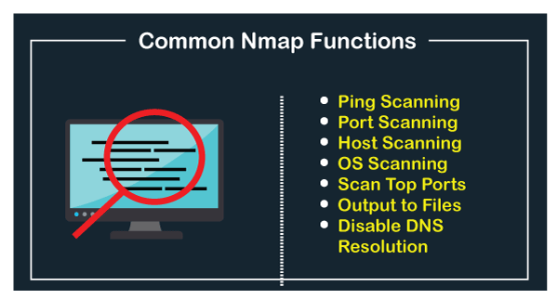

**How it works?**

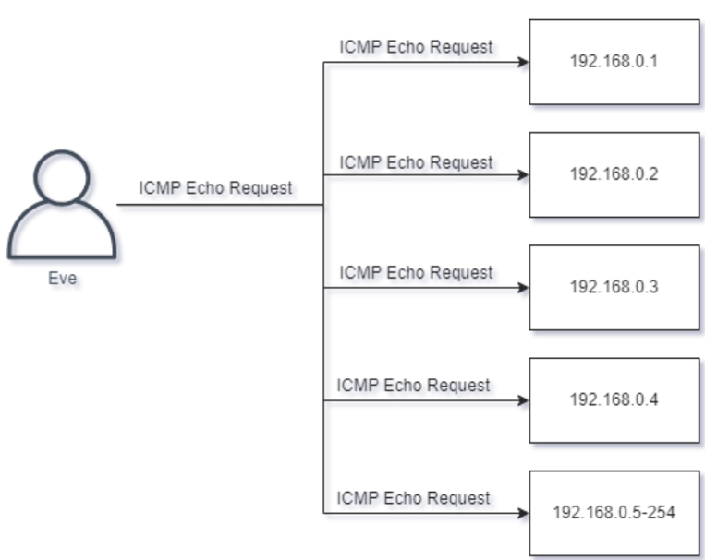

1. Host Discovery: Nmap starts by identifying which hosts are alive and responsive on the network. It does this through techniques like ICMP ping, TCP ping, or ARP scanning, depending on the specified options.
2. Port Scanning: Once hosts are discovered, Nmap conducts port scanning to determine which ports are open and listening on the target systems. This involves sending TCP and UDP packets to various port numbers.
3. Service Detection: For open ports, Nmap sends probes to determine the services running on those ports. It may send specific payloads to elicit responses that reveal information about the services and their versions.
4. OS Fingerprinting: If enabled, Nmap can perform OS fingerprinting by analysing responses from the target systems to certain probes. This helps in identifying the operating system.
5. Scripting: The Nmap Scripting Engine (NSE) can execute scripts that perform various tasks, including vulnerability scanning, banner grabbing, and custom network enumeration, among others.
6. Output and Reporting: Nmap generates reports in the specified output format, providing information about the discovered hosts, open ports, services, and more.

Although my research is not going to investigate all these features in depth, I am focusing mainly on the first 4 features.

1. **Model Overview: Security threat modelling**

**3.1 Background to Security threat modelling**

Threat modelling provides a systematic way to identify threats that might compromise security, and it is a well-accepted practice in the cyber security industry.

*The following steps were taken during the Network Scan through Nmap over by domestic network.*

**Identifying assets**

Assets in a domestic network can include:

* Router/gateway (Connection to the internet)
* Smart devices (IoT devices like thermostats, lights, etc.)
* Computers/laptops/Smartphones (Workstations)

**Entry points might include:**

* Open ports discovered using Nmap (services like HTTP, SSH, etc.)
* Public IP addresses

**Vulnerability Identification**

* Nmap can reveal open ports and services. For each service, look for known vulnerabilities. Example : Use Nmap’s version detection feature with -sV to identify software versions.
* Check for any unencrypted services (HTTP vs. HTTPS, Telnet vs. SSH).

1. **Methodology**

The following tools were used to conduct this research:

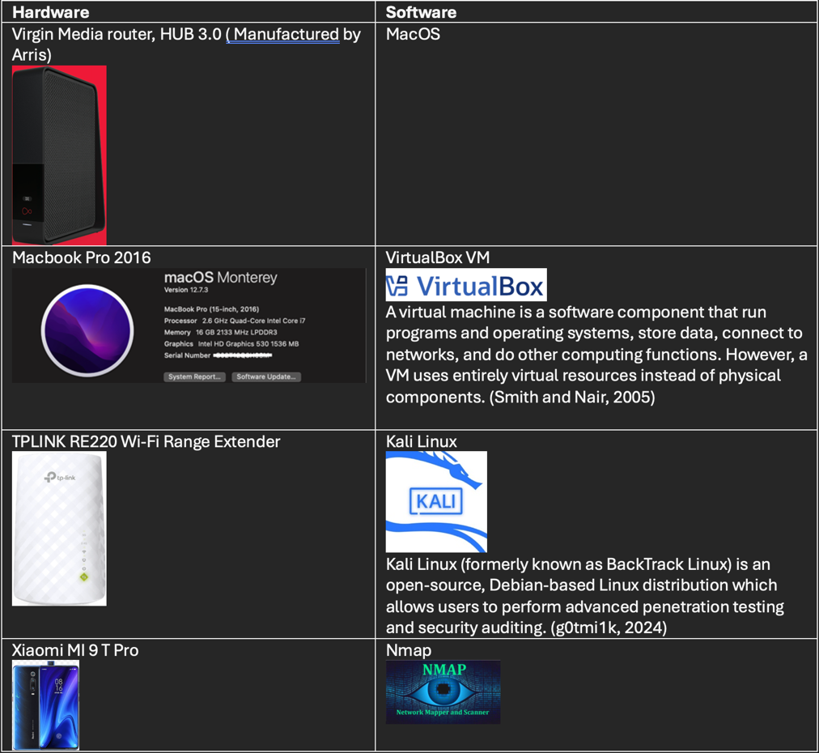

I am aware that my laptop and smartphone are linked to the Wi-Fi because I share a home with three other people.   
However, what about every other gadget? How can I learn more about them? What can be found? We should have a quick look.  
Consider the following scenario: I am a malevolent actor who installs a public wi-fi network in a busy location. I would like to verify which devices are linked to the network.

**4.1 Investigation: Locating and exploring the devices connected to the network**

1. Open VirtualBox Virtual machine
2. Launch Kali Linux
3. Launch Terminal

**First**, we want to determine our public and private IP addresses. We can run the following commands: ip a (This will show us our private IP address)

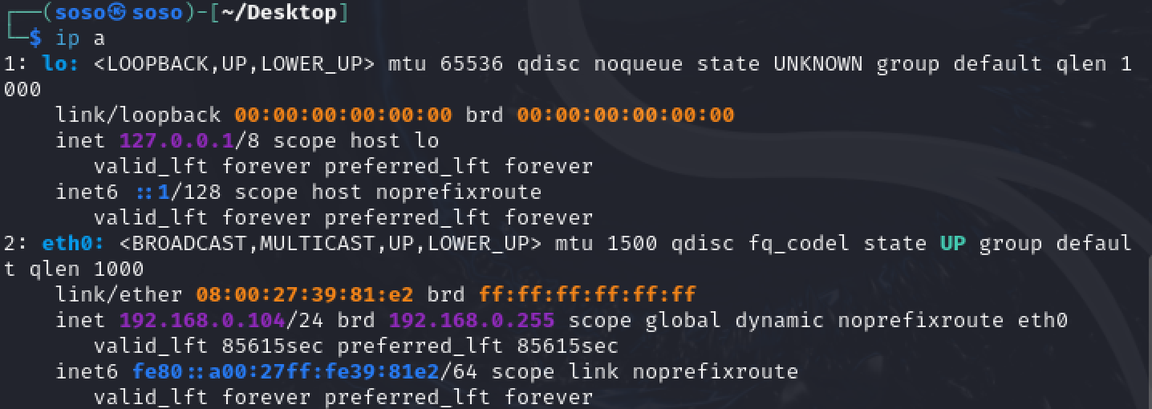

Figure . Ip address retrival

* curl ifconfig.me (Retrieve my public IP address)



*Curl is a command-line utility for transferring data from or to a server that works without user interaction.*(“curl,” n.d.) In this case, the virtual machine that runs the Kali Linux OS automatically detects that the host machine, my MacBook, is connected to the internet, so it takes the connection as a wired network.

**Now that I have both my private IP address and the Public IP address provided by my ISP, I can start my investigation.**

By default, Nmap comes preinstalled in Kali Linux. Therefore, there is no need to initiate an installation. We can open the terminal and type 'nmap'.

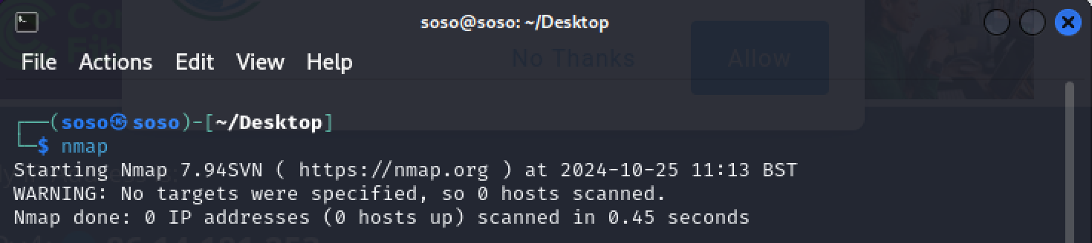

1. Simple host discovery

The first step in network scanning is host discovery, revealing active devices on the network.

Here is that command: nmap 86.14.181.253

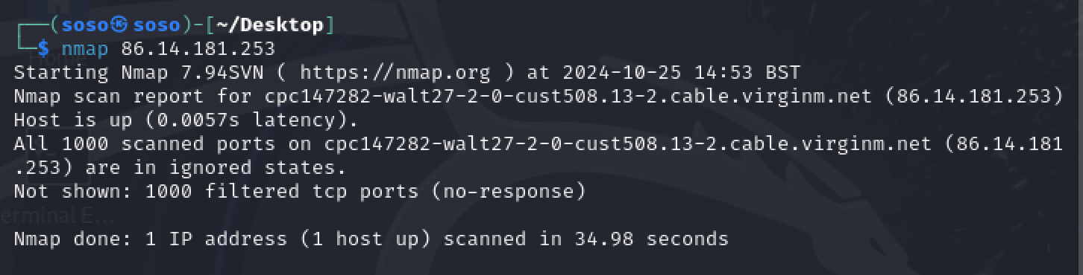

**This targets the public IP address of my router, or IP provider.**

This scan shows me only 1 host, which is the wired connection my Kali Linux OS is using through the Virtual machine through a NAT. Since the ISP’s router have also a private IP address which can be used to check the network details and other configurations, we will try to scan that.

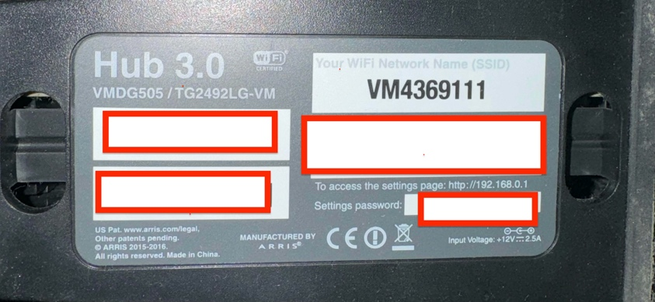

The address is 192.168.0.1:

We will use the command nmap -sP where ‘s’ stand for Scan and ‘P’ for ping as we are automatically pinging devices connected to our network, and the IP address we want to scan.

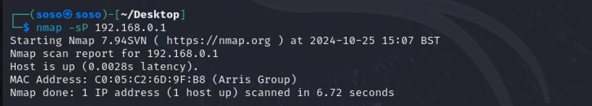

I can see that a device from ‘Arris Group’ is connected to my network. This is my domestic router provided by Virgin Media.

**This is how we can discover the devices connected to a network.**

**2. Detect ports**

We can type : sudo nmap -sT ( Where T is for TCP connect scan) <ip address>

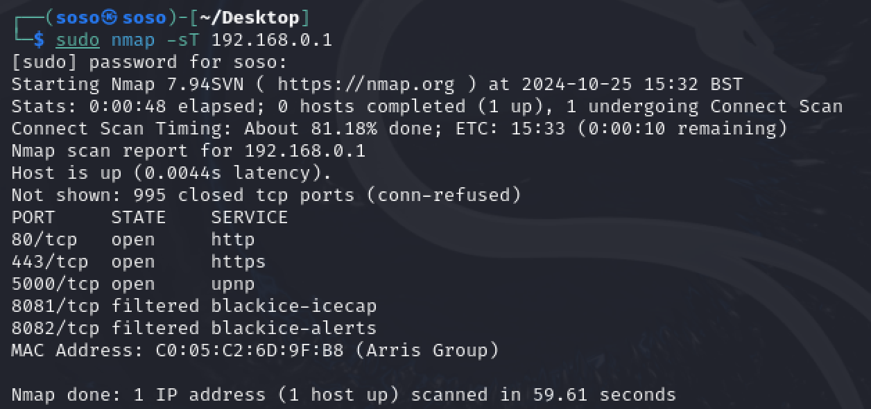

This presents a list of services running in the device, along with their ports.

We can also target specific port in this case for service identification, like Port 80 and Port 443 that are commonly used for web servers.

We can type : sudo nmap -sT -p 80,443 <ip address>

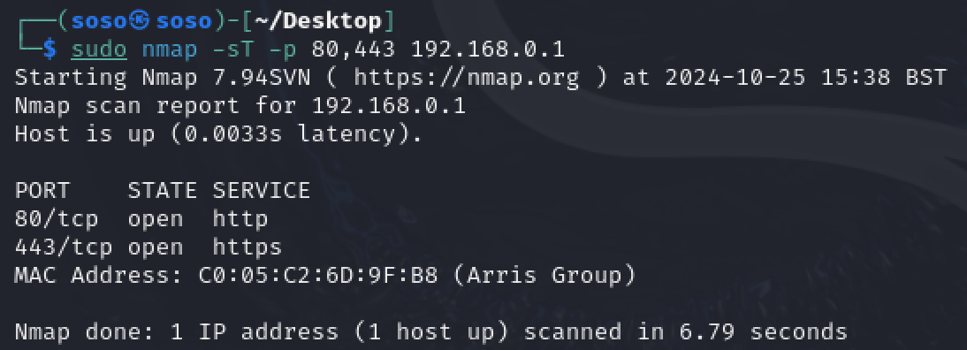

3.Detect the OS of a device:

Now we want to check what OS is running on a specific device.

We can type : sudo nmap -O <local ip address>

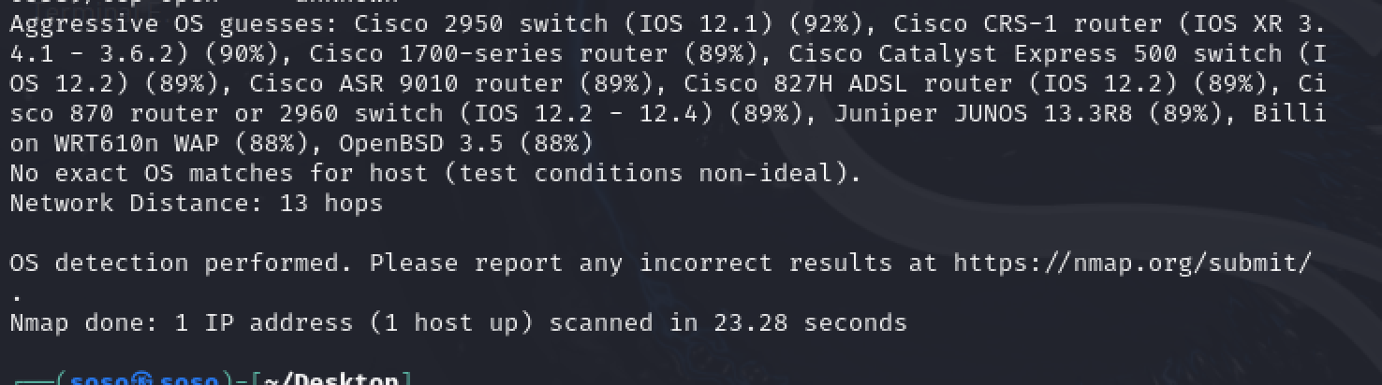

We can see that Nmap tries to guess what OS a spefici device is running.

We can further investigate this feature by checking again, by using performing an aggressive check with : sudo nmap -A 192.168.0.1

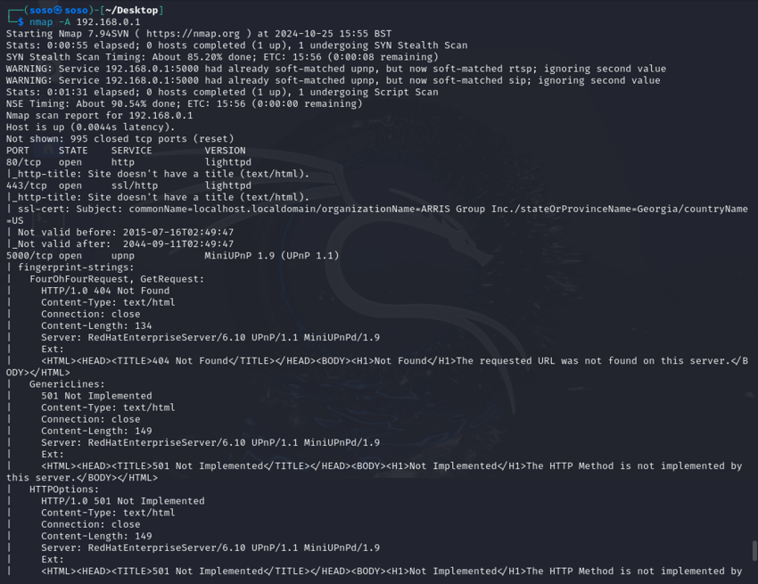



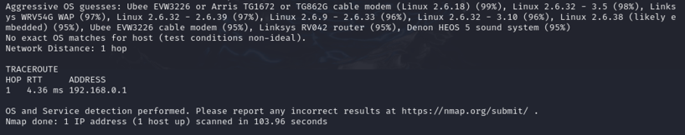



After an aggressive search, Nmap produced the following results:

* OS detection ( Nmap guessed at 99% that the model is running a Linux 2.6.18 OS)
* Protocol version check ( It shows what version of SSL certificate running, as well as start and expire date.)
* Traceroute ( Determine the distance between the network and target device)

1. **Vulnerability discovery**

**Nmap** allows user to run scripts through its Scripting Engine, to find out if there is any vulnerability that can be exploited on a targeted device. The official [Nmap website](https://nmap.org/nsedoc/categories/vuln.html) provide a list of scripts.

We can run the command : sudo nmap –script vuln 192.168.0.1

(This command specify that we want to run a script with all the vulnerabilities on a targeted device)

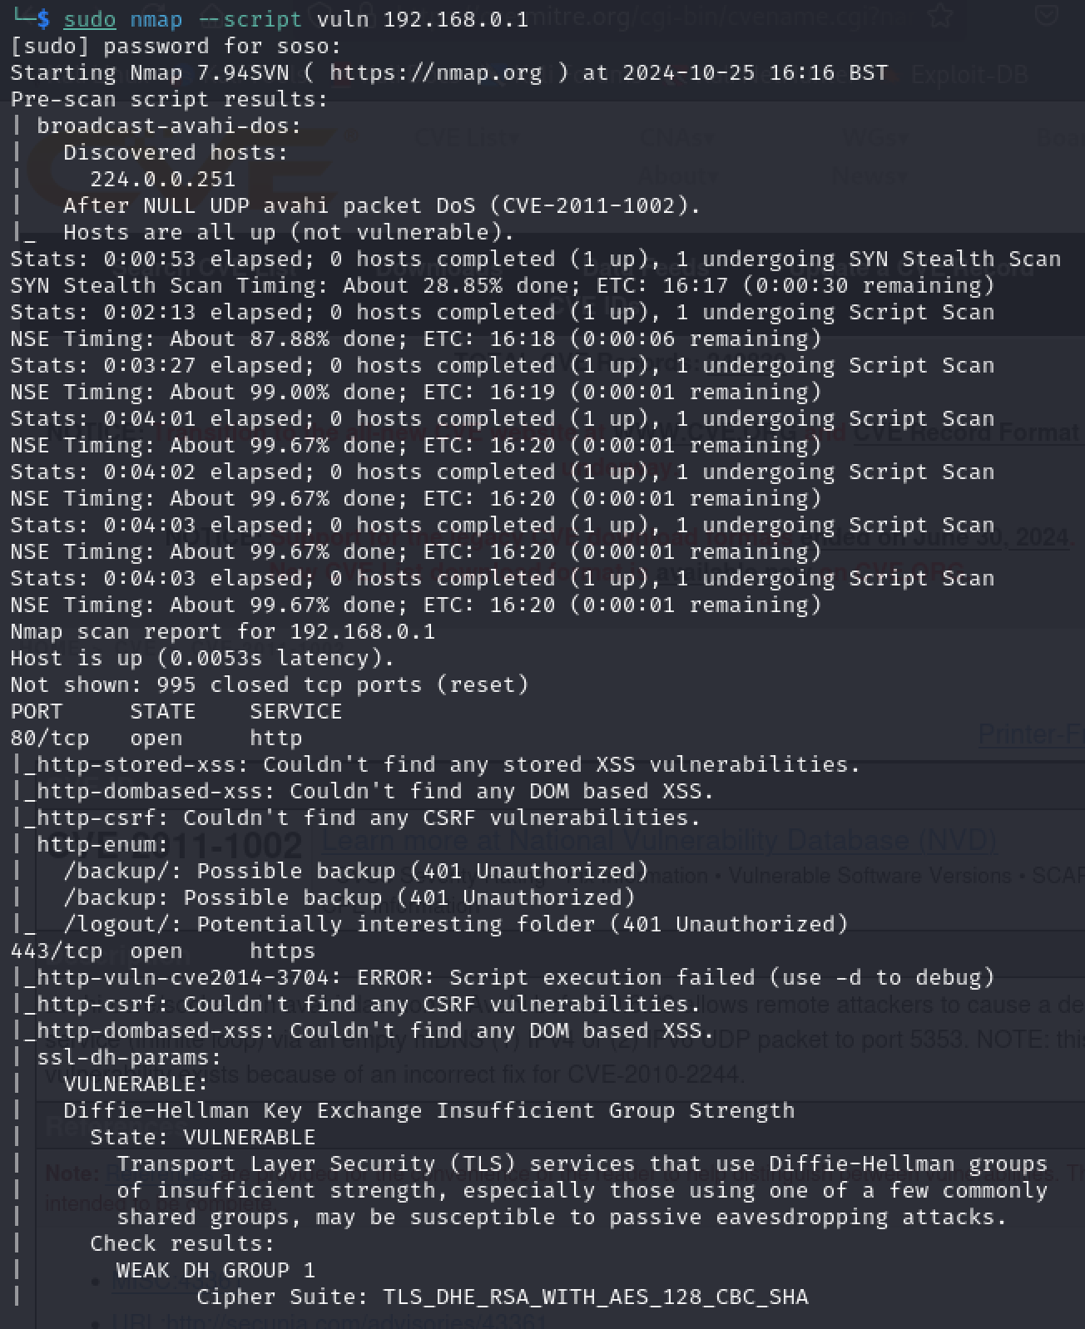

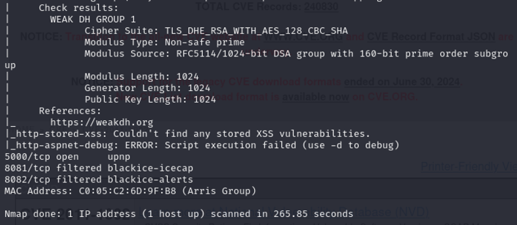

We can see that the result advices us about the SSL-dh parameter , which is considered vulnerable.

Nmap archive shows [here](https://nmap.org/nsedoc/scripts/ssl-dh-params.html) how this can be exploited.

If I try to establish a TCP handshake on port 80( http), which is open:

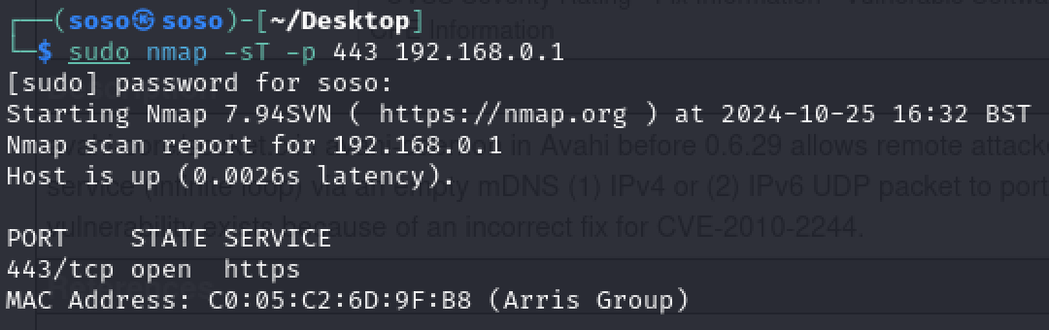

**We can see that the port is ‘OPEN’ and we can establish a connection, which is an ideal exploitable scenario for hackers.**

**Conclusion**

Using host discovery, TCP scanning, operating system detection, and service version detection proactively is essential in today's linked and digitalised world, where network security threats are always changing. Organisations may build a strong foundation for preserving a strong and secure network architecture, safeguarding important data, and staying ahead of possible cyber-attacks by routinely implementing these strategies. To ensure that security procedures are both efficient and responsible, it is crucial to carry out these tasks within the bounds of moral and legal concerns.

**References**

**AC750 Wi-Fi Range Extender [WWW Document], n.d. URL** [**https://www.tp-link.com/uk/home-networking/range-extender/re220/**](https://www.tp-link.com/uk/home-networking/range-extender/re220/) **(accessed 10.25.24).**

**Adekola, 2023. The Evolution of Internet Service Providers - SwiftTalk Limited. URL** [**https://swifttalk.net/2023/10/18/the-evolution-of-internet-service-providers/, https://swifttalk.net/2023/10/18/the-evolution-of-internet-service-providers/**](https://swifttalk.net/2023/10/18/the-evolution-of-internet-service-providers/,%20https:/swifttalk.net/2023/10/18/the-evolution-of-internet-service-providers/) **(accessed 10.22.24).**

**An Overview of Kali Linux: Empowering Ethical Hackers with Unparalleled Features | Request PDF [WWW Document], n.d. URL** [**https://www.researchgate.net/publication/378304140_An_Overview_of_Kali_Linux_Empowering_Ethical_Hackers_with_Unparalleled_Features**](https://www.researchgate.net/publication/378304140_An_Overview_of_Kali_Linux_Empowering_Ethical_Hackers_with_Unparalleled_Features) **(accessed 10.25.24).**

**Ashwani K, 2023. What is Nmap and use cases of Nmap? DevOpsSchool.com. URL** [**https://www.devopsschool.com/blog/what-is-nmap-and-use-cases-of-nmap/**](https://www.devopsschool.com/blog/what-is-nmap-and-use-cases-of-nmap/) **(accessed 10.23.24).**

**Bandlekar, R., 2023. Nmap 101: A Beginner’s Guide to Network Mapping and Security. Medium. URL** [**https://ravitejbandlekar.medium.com/nmap-101-a-beginners-guide-to-network-mapping-and-security-a7ec875e52b**](https://ravitejbandlekar.medium.com/nmap-101-a-beginners-guide-to-network-mapping-and-security-a7ec875e52b) **(accessed 10.23.24).**

**Bautista, M.A.D., 2021. How to understand and develop a Nmap of your Own — Part 1 — CyberForged [WWW Document]. Medium. URL** [**https://infosecwriteups.com/how-to-understand-and-develop-a-nmap-of-your-own-part-1-cyberforged-ee92dd4bb901**](https://infosecwriteups.com/how-to-understand-and-develop-a-nmap-of-your-own-part-1-cyberforged-ee92dd4bb901) **(accessed 10.23.24).**

**Bendovschi, A., 2015. Cyber-Attacks – Trends, Patterns and Security Countermeasures. Procedia Economics and Finance, 7th INTERNATIONAL CONFERENCE ON FINANCIAL CRIMINOLOGY 2015, 7th ICFC 2015, 13-14 April 2015,Wadham College, Oxford University, United Kingdom 28, 24–31.** [**https://doi.org/10.1016/S2212-5671(15)01077-1**](https://doi.org/10.1016/S2212-5671(15)01077-1)

**Bhavsar, M., Sharma, D.P., Gokani, M., 2017. Port scanning using Nmap. IJEDR 5, 1536–1537.**

**Chalhoub, G., Martin, A., 2023. But is it exploitable? Exploring how Router Vendors Manage and Patch Security Vulnerabilities in Consumer-Grade Routers, in: Proceedings of the 2023 European Symposium on Usable Security, EuroUSEC ’23. Association for Computing Machinery, New York, NY, USA, pp. 277–295.** [**https://doi.org/10.1145/3617072.3617110**](https://doi.org/10.1145/3617072.3617110)

**curl [WWW Document], n.d. URL** [**https://curl.se/**](https://curl.se/) **(accessed 10.25.24).**

**Deshpande, A., 2014. An examination of the evolution of broadband technologies in the UK 453.** [**https://doi.org/10.21954/ou.ro.00009fa9**](https://doi.org/10.21954/ou.ro.00009fa9)

**Editor, C.C., n.d. Cyber Attack - Glossary | CSRC [WWW Document]. URL** [**https://csrc.nist.gov/glossary/term/cyber_attack**](https://csrc.nist.gov/glossary/term/cyber_attack) **(accessed 10.23.24).**

**Ferazza, F.M., 2022. CYBER KILL CHAIN, MITRE ATT&CK, AND THE DIAMOND MODEL: A COMPARISON OF CYBER INTRUSION ANALYSIS MODELS. Royal Holloway University of London 91.**

**g0tmi1k, 2024. What is Kali Linux? | Kali Linux Documentation [WWW Document]. Kali Linux. URL** [**https://www.kali.org/docs/introduction/what-is-kali-linux/**](https://www.kali.org/docs/introduction/what-is-kali-linux/) **(accessed 10.25.24).**

**Gavin Wright, 2021. What are ports in computing and how do they work? [WWW Document]. Networking. URL** [**https://www.techtarget.com/searchnetworking/definition/port**](https://www.techtarget.com/searchnetworking/definition/port) **(accessed 10.22.24).**

**Gordon Lyon, 2022. Nmap Network Scanning [WWW Document]. https://nmap.org/book/toc.html. URL** [**https://nmap.org/book/toc.html**](https://nmap.org/book/toc.html) **(accessed 10.22.24).**

**Gordon Lyon, n.d. Chapter 15. Nmap Reference Guide | Nmap Network Scanning [WWW Document]. URL** [**https://nmap.org/book/man.html**](https://nmap.org/book/man.html) **(accessed 10.22.24a).**

**Gordon Lyon, n.d. The Phases of an Nmap Scan | Nmap Network Scanning [WWW Document]. URL** [**https://nmap.org/book/nmap-phases.html**](https://nmap.org/book/nmap-phases.html) **(accessed 10.23.24b).**

**Holm, H., 2012. Performance of automated network vulnerability scanning at remediating security issues. Computers & Security 31, 164–175.** [**https://doi.org/10.1016/j.cose.2011.12.014**](https://doi.org/10.1016/j.cose.2011.12.014)

**Huawei Technologies Co., Ltd. (Ed.), 2023. Virtualization Technology, in: Cloud Computing Technology. Springer Nature, Singapore, pp. 97–144.** [**https://doi.org/10.1007/978-981-19-3026-3_3**](https://doi.org/10.1007/978-981-19-3026-3_3)

**Karamanos, E., 2010. Investigation of home router security.**

**Kaspersky, 2022. 87 critical vulnerabilities discovered in routers in 2021 [WWW Document]. 87 critical vulnerabilities discovered in routers in 2021. URL** [**https://www.kaspersky.com/about/press-releases/87-critical-vulnerabilities-discovered-in-routers-in-2021**](https://www.kaspersky.com/about/press-releases/87-critical-vulnerabilities-discovered-in-routers-in-2021) **(accessed 10.22.24).**

**Liao, S., Zhou, C., Zhao, Y., Zhang, Z., Zhang, C., Gao, Y., Zhong, G., 2020. A Comprehensive Detection Approach of Nmap: Principles, Rules and Experiments, in: 2020 International Conference on Cyber-Enabled Distributed Computing and Knowledge Discovery (CyberC). Presented at the 2020 International Conference on Cyber-Enabled Distributed Computing and Knowledge Discovery (CyberC), pp. 64–71.** [**https://doi.org/10.1109/CyberC49757.2020.00020**](https://doi.org/10.1109/CyberC49757.2020.00020)

**Liu, L., 2020. Discussion and Practice of Computer Network Information and Network Security Protection Strategy, in: 2020 5th International Conference on Mechanical, Control and Computer Engineering (ICMCCE). Presented at the 2020 5th International Conference on Mechanical, Control and Computer Engineering (ICMCCE), pp. 1810–1813.** [**https://doi.org/10.1109/ICMCCE51767.2020.00397**](https://doi.org/10.1109/ICMCCE51767.2020.00397)

**Makenzie Buenning, 2024. How to Use Nmap: Complete Guide with Examples | NinjaOne [WWW Document]. URL** [**https://www.ninjaone.com/blog/how-to-use-nmap-complete-guide-with-examples/**](https://www.ninjaone.com/blog/how-to-use-nmap-complete-guide-with-examples/) **(accessed 10.23.24).**

**Mazurczyk, W., Caviglione, L., 2021. Cyber Reconnaissance Techniques. Communications of the ACM 64.** [**https://doi.org/10.1145/3418293**](https://doi.org/10.1145/3418293)

**Mitra, R., Brown, G., Huffman, M., Zhu, H., 2023. Telecommunications and Networking. The University of Texas at San Antonio.**

**Odun-Ayo, I., Owoka, E., Okuoyo, O., Ogunsola, O., Ikoh, O., Adeosun, O., Etukudo, D., Robert, V., Oyeyemi, G., 2022. Evaluating Common Reconnaissance Tools and Techniques for Information Gathering. Journal of Computer Science 18, 103–115.** [**https://doi.org/10.3844/jcssp.2022.103.115**](https://doi.org/10.3844/jcssp.2022.103.115)

**Ouyang, F., Duvaut, P., Moreno, O., Pierrugues, L., 2003. The first step of long-reach ADSL: smart DSL technology, READSL. IEEE Communications Magazine 41, 124–131.** [**https://doi.org/10.1109/MCOM.2003.1232247**](https://doi.org/10.1109/MCOM.2003.1232247)

**Sandra Henry Stocker, 2018. Using nmap on your home network [WWW Document]. Network World. URL** [**https://www.networkworld.com/article/966532/using-nmap-on-your-home-network.html**](https://www.networkworld.com/article/966532/using-nmap-on-your-home-network.html) **(accessed 10.22.24).**

**Smith, J.E., Nair, R., 2005. The architecture of virtual machines. Computer 38, 32–38.** [**https://doi.org/10.1109/MC.2005.173**](https://doi.org/10.1109/MC.2005.173)

**Surarapu, P., Mahadasa, R., 2023. An Overview of Kali Linux: Empowering Ethical Hackers with Unparalleled Features 1, 171–180.**

**The History and Future of Nmap | Nmap Network Scanning [WWW Document], n.d. URL** [**https://nmap.org/book/history-future.html**](https://nmap.org/book/history-future.html) **(accessed 10.23.24).**

**Wattuhewa, S., 2023. Network Scanning with Nmap.**